SPRINT-4

|  |  |
| --- | --- |
| Team ID | PNT2022TMID43975 |
| Project Name | IoT based smart crop protection for agriculture |

Node JS installation :

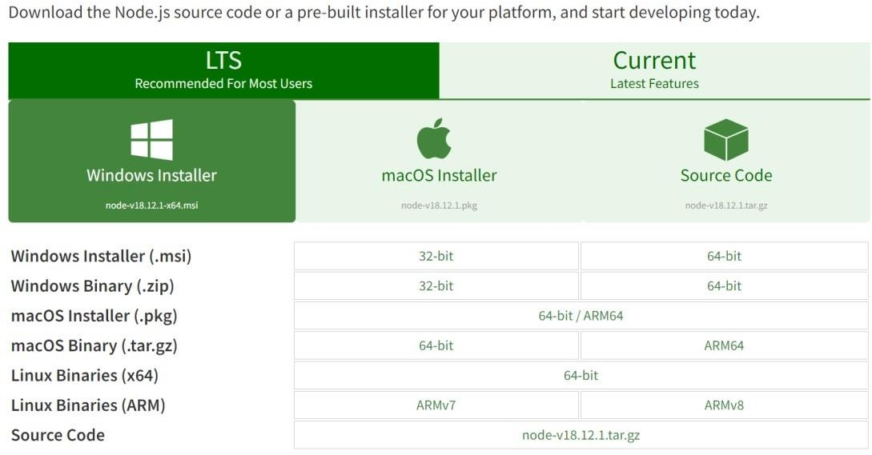

Configure command prompt for error check .open node-red from the generated link:

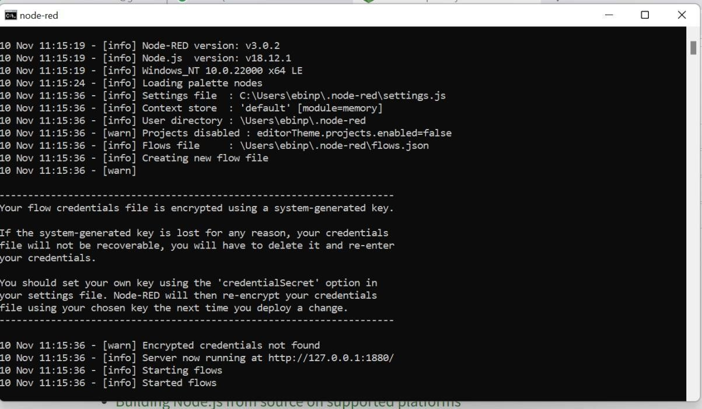

Connection IBM IOT in debug 1 and deploy:

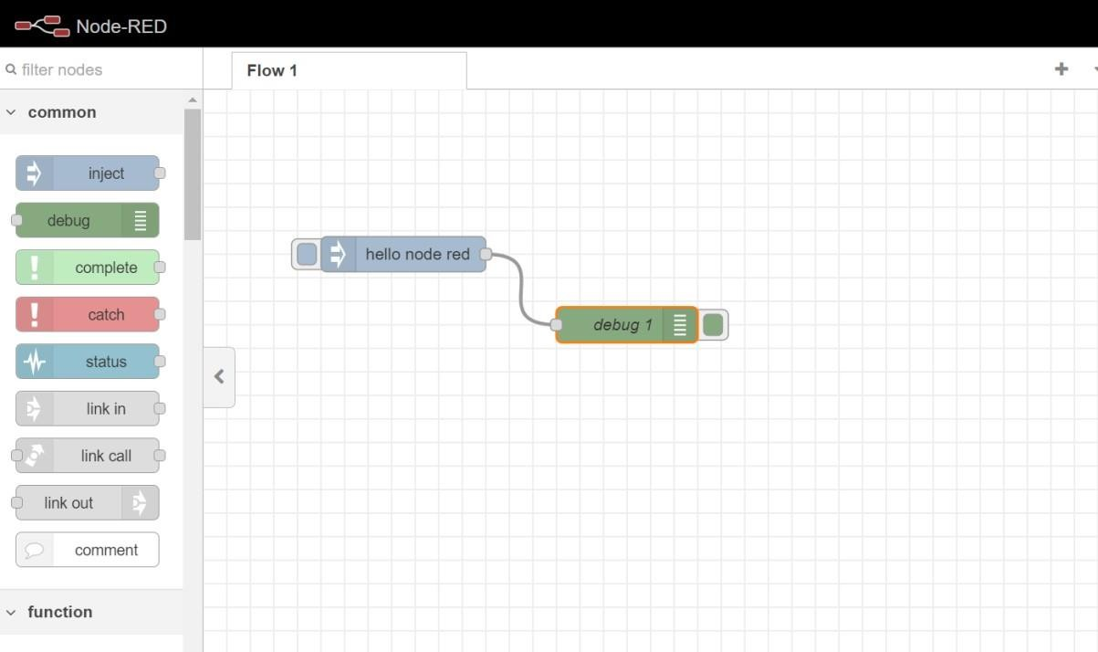

**Output:**

